The Case of

€2.5 Million Robbery

using velocity calculations to solve a crime

Alison Graham
Teachers notes
The case of The €2.5 million Robbery
____________________________
Syllabus links:
Junior Certificate Science: OP1 Perform simple calculations based on…….speed….
Equipment required:
Ruler
Opisometer / string / thread to measure the distance on the map
Calculator
What you need to do in advance:
Photocopy worksheet including map

Expected results:
- There are 2 ways of doing this- working out the time needed to cover the distance and comparing the estimated arrival time with the crime time line or working out the time available and hence the speed required from the suspect to get there and comparing with the speed chart to see if that is possible
 | Dist on map | Distance | Speed | Time needed | Arrival time
A | 16 cm | 1600m | 1.5m/s | 1067s=17.7min | 7.36 am
B | 15 cm | 1500m | 5m/s | 300s=5min | 7.20 am
C | 14.5cm | 1450m | 1.5m/s | 967s=16min | 7.26am
D | 10.5cm | 1050m | 1.5m/s | 700s=12min | 7.37 am

2.
A | 12cm | 1200m | 1.5m/s | 800s=13.3min | 7.58am
B | 17.5cm | 1750m | 5m/s | 350s=6min | 7.51am
C | 15.5cm | 1550m | 1.5m/s | 1033s=17min | 8.02am
D | 17.5cm | 1750m | 11m/s | 159s=3min | 7.48am

3. The results suggest that
(i) B and C could have been at the Maxol Garage
(ii) B and D could have been at Killester Sports Ground
4. Lots of possibilities here- a few options ……
Defending B : the 5m/s used is an average. It was rush hour and the roads in the area are not wide and so traffic was slow at that time
Defending C: C is quite old and although could walk at that paec for a short time could not maintain it for long

5. Lots of possibilities
Suspect C: Could have got a lift to the golf club- he left the sports ground in a van
Suspect A; Could have got a lift to near his home with Suspect D

6. This is open ended with lots of possibilities. The crime has not been solved yet and is still under investigation so who knows…

Student worksheet
The Case of €2.5 Million Robbery
The crime
On 30th March 2005 €2.5 million was stolen from a Brinks Allied cash transit van in Artane.

7.15am: Security van leaves Brinks Allied Depot in Clonshaugh, north Dublin, with a multi-million cash delivery for outside Dublin. It travels down Kilmore Road, towards Skelly's Lane roundabout in Artane.
7.25am: Security van pulls into Maxol Station on Skelly's Lane. The driver of the van gets out and buys takeaway coffees for himself and his two colleagues.
7.30am: As he walks back, a loan gunman pounces on him, puts a gun in his face and orders him back to the van. The gunman threatens him and his colleague in the front seat of the van and tells them to drive to the sports ground in nearby Killester
.
7.35am: Security van parks in the Killester Sports Ground, near the Howth Road, which is the main thoroughfare out of the city.
There, they are met by at least two other masked gang members travelling in a white transit van and blue 4X4 with bullbars. The third security employee in the back of the van is ordered to hand out the cash, thought to amount to between €2.4m and €2.7m.
The gang escapes in the two vehicles. The white transit van has a false registration plate 97 O ****
7.45am: Vans leave and security workers raise the alarm. Garda patrol cars rush to the scene

There are 4 suspects but all with alibis for certain times that morning. Could they have been at the crime scene?

What you need to know!
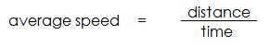
Speed is the distance moved in a certain time. It is usually measured in km per hour for road users but scientists also use metres per second. You can calculate speed using the formula:
In the table below are some speeds which are going to be useful.

 | speed in m/s | speed in km/h
average walking speed | 1 – 1.5 | 3.6 – 5.4
speed of a sprinter | 10 | 36
speed of car on city streets | 11 – 17 | 40 - 60
typical speed of road cyclist | 5 | 20
speed of car on major road | 30 | 108
maximum speed of a Ferrari | 105 | 380
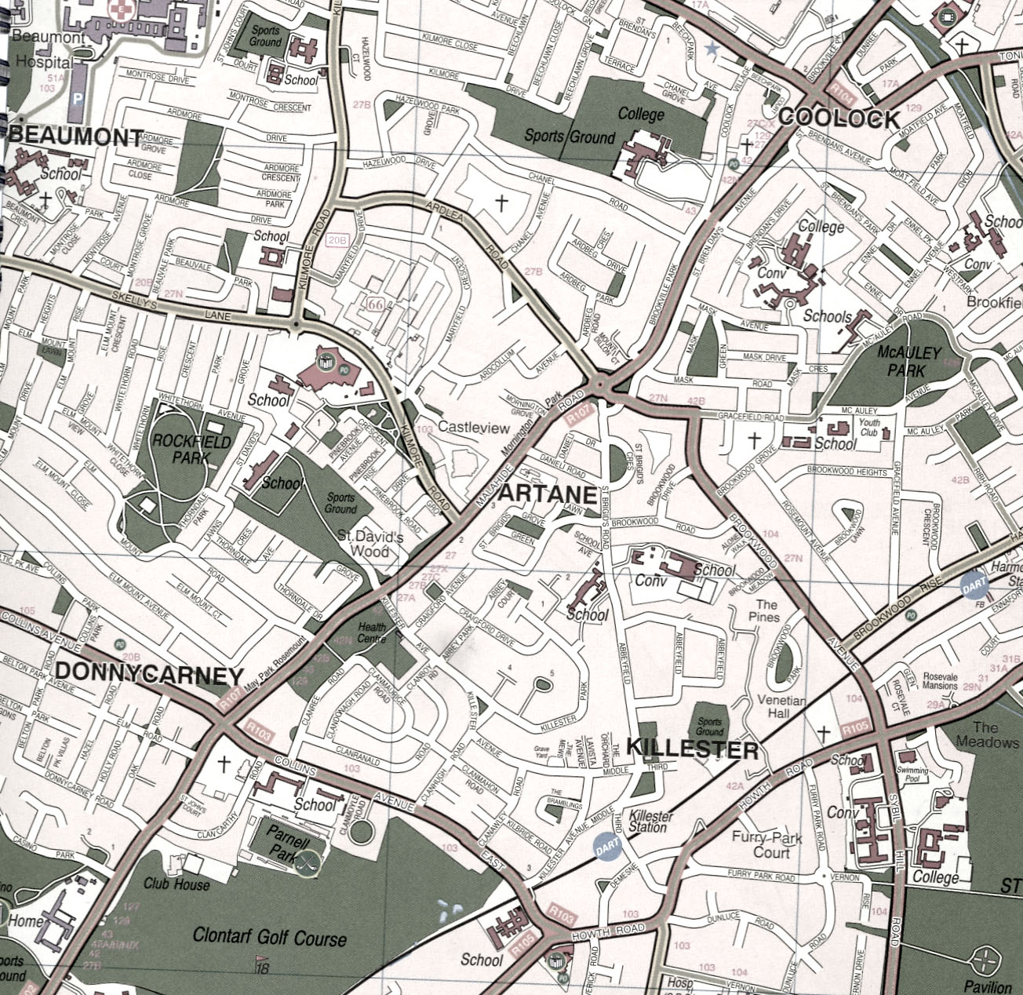
This is a map of the area of the robbery (scale 1:10000)
This means that 1cm on this map represents 10000 cms or 100m on the ground.
Chanel College
Sports ground,
Killester
Maxol Garage
What you need to do to solve the crime!

Some of the suspects are well known members of Dublin criminal gangs – we are not using real names as we do not wish to prejudice future court proceedings.

Suspect A is a well known member of the Dublin criminal world. He lives at the corner of the roads McAuley Park and McAuley Drive near McAuley Park. A neighbour saw him leave the house on foot at exactly 7.18 a.m. on the day of the robbery and return at 7.50 am. He said that he was going for a walk

Suspect B is a teacher at Chanel College. He always used to cycle to school but has recently bought a brand new BMW . On the day of the robbery he left home at the corner of Collins Avenue East and Killester Avenue at 7.15am( he had lots to do for a subject inspection)and was seen cycling into the college at the earlier than usual time of 8.10am.

Suspect C lives in Howth and said that he travelled on the Dart to his regular golf match early that morning. He was seen leaving Killester Dart station at 7.10 am He and his colleagues were seen in the Club House of Clontarf Golf Club cctv at 7.55 am

Suspect D was seen getting out of a van at the junction of Collins Avenue and the Malahide Road at 7.25am He was dropped at work by a red car at Chanel College, where he is a groundsman a little late at 8.05 am

1. Which of the suspects could have been the gunman at the Maxol Garage?
Use your knowledge of speed to find out. Show all your working out. You will need to find the distance he needs to travel and take into account his likely speed and the time available!

Suspect A …………………………….. Suspect B …………………………………
……………………………………….. …………………………………………….
……………………………………….. …………………………………………….
……………………………………….. …………………………………………….
……………………………………….. …………………………………………….
………………………………………. ……………………………………………..

Suspect C …………………………… Suspect D ………………………………….
……………………………………… ………………………………………………
……………………………………… ………………………………………………
………………………………………. ………………………………………………
……………………………………… ………………………………………………
……………………………………… ………………………………………………
2. Which of the suspects could have been at the money transfer in the Sports ground at Killester?

Suspect A …………………………….. Suspect B …………………………………
……………………………………….. …………………………………………….
……………………………………….. …………………………………………….
……………………………………….. …………………………………………….
……………………………………….. …………………………………………….
………………………………………. ……………………………………………..

Suspect C …………………………… Suspect D ………………………………….
……………………………………… ………………………………………………
……………………………………… ………………………………………………
………………………………………. ………………………………………………
……………………………………… …………………………………………….

3. From your calculations which of the suspects could have been
(i) the gunman at the Maxol Garage ……………………………………..
(ii) at the money transfer at Killester Sports Ground ………………………………………

4. Assume you are the barrister defending one of the suspects above. What arguments could you make against the speed evidence which shows that it was possible that he was at the crime scene?
……………………………………………………………………………………………………………………………………………………………………………………………………………………………………………………………………………………………………………………………………………………………………………………………………………………………………………………………………………………………………………………………………………………………………………………………..
5. Assume you are the barrister prosecuting one of the suspects who seems to have a good alibi according to the speed data. What arguments could you make against the speed data?
………………………………………………………………………………………………………………………………………………………………………………………………………………………………………………………………………………………………………………………………………………………………………………………………………………………………………………………………………………………………
6. Which of the suspects do you think is involved? What other evidence would you need to collect to prove it?
……………………………………………………………………………………………………………………………………………………………………………………
………………………………………………………………………………………………………………………………………………………………………………………………………………………………………………………………………………

